TRAFFIC TRAINING
by
Jo Ann Keith
KA5AZK

June 1, 2019

ACKNOWLEDGEMENTS
Compiled by Jo Ann Keith KA5AZK
June 1, 2019

My thanks to the following fellow Hams

John Keith W5BWC
For his help and support

Steve Phillips K6JT
For his help with the NTS info and Net Frequency List

ARRL
For their training materials

IN THE BEGINNING
AND
WHAT IS TRAFFIC

Amateur Radio started out as a scientific hobby but quickly it was realized that Hams could provide a great public service. Back at the turn of the century, Marconi was the first to prove that a message could be relayed by wireless from one point to another. Our Military realized the Amateur’s usefulness in the years after the first World War and the formation of MARS was established in 1925 as then the Army-Amateur Radio System. During MacMillan’s expedition to the Arctic on the schooner Bowdoin in 1923, Amateurs provided communications between the schooner and the adventures homes. Then, as now, Hams have proven their ability to communicate when there are no other ways to do so.

So what is Traffic? No it’s not something that you set in for long periods of time on the Interstate, it has become known as the messages that are passed from one point to another. There are several parts to a message or piece of traffic that will be covered later on. A standard form or method of writing up a message has evolved over the years by Amateurs that have participated in passing a great number of pieces of traffic. It was found that a standard form for everyone to use was the most efficient and fastest way to transmit a message. There are many different ways to transmit a piece of traffic such as, on SSB, CW and many different ways on the new technology that is available today with the computer. But with all them you will use the same basic form.

WHY LEARN TRAFFIC HANDLING

In this day of cell phones and digital technology the need for learning traffic handling, nets in general and Ham Radio for that matter might seem obsolete. An emergency of some sort, such as the last two Gulf Coast hurricanes and the shuttle crash, proved that is not the case. We may not handle traffic in the same way or in the amount we did years ago but just like CW, there is still a need.

During the hurricanes it became very obvious that there is a need for Hams to learn how to check into nets and what is meant by a piece of traffic. Cell phone towers can blow over and the back up power to the sites can either not work or be used up if the emergency goes on long enough. Cell phones don’t always work in some areas; such was the case during the shuttle crash. During the hurricanes people were checking into nets that had never done so before and didn’t know the procedures or the disciplines of the net. What was needed and not needed in a health and welfare message was not known in a lot of cases.

A traffic net during an emergency is a hectic place and is made even worse by stations not knowing the correct way or the net’s way of doing things. As a matter of fact,
inexperience and lack of knowledge can hinder a net’s operation greatly. The people on a net become like a family and the net controls learn to know calls, names and locations and therefore will know who can take what message. This makes it so much easier during an emergency to run the net smoothly.

Just as in the early days of Amateur Radio, emergency response organizations are continuing to find out that Hams can help with communications when there is no other way. We need to be prepared so that Ham Radio will be known as helpful and knowledgeable group.

DURING AN EMERGENCY IS NOT THE TIME TO LEARN HOW TO PASS OR WRITE A PIECE OF TRAFFIC OR LEARN HOW TO CHECK INTO A NET. If you are not familiar with either, then LISTEN and learn before there is an actual emergency.

BASIC NET OPERATIONS

A Net is a group of Hams that come together with a common interest. Some of us are interested in traffic or message handling, some rag-chewing, some DXing and on and on. Each net has its own way of asking for stations to check in. Most will read a preamble that will instruct you on how they want you to check in. Listen carefully to those instructions and how everyone else checks in. During an emergency this will be probably be different and is even more important. Some nets, during emergency situations, will only take check ins when there is a need. In other words you listen only. Some are for official use such as, the ARES Net that preempts the Daytime Texas Traffic Net on 7285 in emergencies. That Net is then used by officials such as Salvation Army, EOCs, city officials and other organizations of that sort. Other Nets handle health and welfare traffic and general information, such as the 7290 Traffic Net. Still other Nets track hurricanes and the list goes on and on.

It was found that having set schedules for stations to meet (nets) to exchange or relay traffic was more efficient than just random schedules. The National Traffic System was established to speed the relaying of traffic between two or more areas of the county. The main idea of the NTS is that traffic can, under normal conditions, can reach its’ destination on the same day it was originated. The NTS is made up, in part, of a Region Net which covers a call area and an Area Net which covers a time zone. Each of these Nets operate several times of the day so that there are several opportunities to pass traffic. There is much more information on the NTS in the ARRL Public Service Communications Manual.

Basic Net Check In Procedure. As stated above, checking into a net will vary with each net. Most will read a preamble that will tell a little about the net, the operating hours and so on. Under normal conditions, some ask for call signs only, some allow call sign and name, and some ask for checkins by state. Almost all will have a standby at the beginning of the net for emergency or priority traffic, anyone that has traffic to list and then general checkins. During the net operation hours, most will pause for additional checkins and stations with traffic. When checking in with traffic and the net control asks you for your traffic, he is asking what city and state your traffic is going to. Do not just start sending your traffic. Sometimes a state area net may not have someone from the city where your traffic is to be delivered in. If this happens, it may take a check in or two to pass your traffic. Don’t hesitate, however, to ask for someone to pick up your traffic to pass later if you can’t return to the net’s next session or be on another net. There will more than likely be someone that goes to several nets that won’t mind doing this. However, it is important for the traffic to go through as few as hands as possible.

When moving off frequency to pass a piece of traffic, it is customary for the receiving station to select the frequency and call the station passing the traffic. This is so the receiving station has a frequency he can hear clearly on and it also prevents both stations calling at once and not hearing each other.

The main idea is to know about these nets and get use to them by checking in and letting the people on the net get use to you and know what your capabilities are. During an emergency is not the time to learn how to check into a net or learn about traffic handling. Be prepared, learn before you need it

THE MESSAGE

There are three ways you may handle a message or piece of traffic:
- Originator – you are the first person to transmit the message. This message will have your number and call in the preamble.
- Relay – you pick up a message or piece of traffic to retransmit to another station either on another net or relay to another station because of band conditions.
- Deliver – you pick up a message or piece of traffic to deliver by phone to the addressee.

The official ARRL Radiogram form can be used to record messages you relay but it is not necessary if you want to use something else. I used the form when I first started taking messages until I got used to the outline then I started using spiral notebooks, one for received messages and one for messages I originated. (I strongly recommend using the Radiogram form until you learn the outline.) Any way of writing down the message is ok, there are programs for the computer available also. If for some reason you need to hand deliver or mail a message for delivery, you will need to use the form for doing that. Notice the box in the upper right corner to be filled in if you hand deliver or mail. The bottom two boxes are for the station you receive the message from and the station you relay the message to. The sent section can also be used for recording when you phone deliver the message. If you use plain paper to record messages, the sent and received box information need to be recorded. There will be times when you will need to know when and where you have relayed a message.

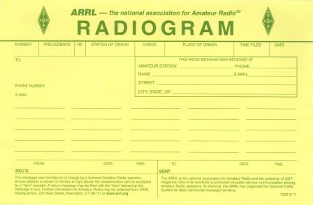

THE FOUR PARTS OF A MESSAGE

NUMBER 1: The heading or preamble which contains the number, the precedence, the handling instructions (HX), the station of origin, the check count, the place of origin, time filed and the date.
NUMBER 2: The address or who the message is going to.
NUMBER 3: The text. (On the form below, one word would go in each block)
NUMBER 4: The signature.

NUMBER 1
The Heading or Preamble Starting with the Message Number

The message number is simply the number assigned to the message by the originating station and stays with the message until it is delivered. Each message should have it’s own number which is chosen by the originating station. Some people use the date the message is written, such as June 7 being 67, or consecutive numbers starting with 1 or 100 or whatever number they chose. Putting 0s in front of the numbers is not necessary and frowned upon by CW nets.

The Precedence
.
The precedence is the type of message it is. There are four different kinds; Emergency, Priority, Welfare and Routine and are written in the precedence block by a P, W or R but are transmitted by the saying the whole word. Emergency is always spelled out. You will see and use Routine most often. Refer to Form FSD-218 page 15.

The Handling Instructions or HX

The handling instructions are just that, they are the way the originating station would like the message handled. There are seven different instructions, HXA, HXB, HXC, HXD, HXE, HXF and HXG. See Form FSB-218, page 15. You will see and use HXG the most. A message may have more than one handling instruction in the heading if it is needed. Transmit the Handling Instructions by saying HOTEL XRAY GOLF. If you use more than one Handling Instruction say HOTEL XRAY GOLF ECHO. Please pay attention to these instructions and if the originator requests a return, originate a message back to him. If you have an HXC and cannot deliver the message, a return (or Service Message) needs to be sent to the originating station informing him.

The Station of Origin

The station of origin is the person that composes and first transmits the message and his/her call stays with the message until it’s delivered. If you write the message it has your number and your call.

The Check

The check is the number of words, word groups, figures or figure groups in the text and is limited to 25 groups. Use this number to verify that you received the message correctly. Try to keep the text as simple as possible without a lot of confusing or long words. If you are getting close to the 25 limit, you may gain a space for a word or two by not using punctuation (covered later) if it doesn’t change the meaning of your text. If you have an ARL Radiogram in the text, there should be an ARL in front of the number in your check count.
The Place of Origin

The place of origin is the city and state the message originated in and also stays with the message until it’s delivered. If for instance, I deliver a message to someone in Longview and they wish to send a reply, the reply would have my call but would have Longview, TX as the place of origin even though I live in Gilmer. The place of origin should be the city the person signing the message lives in.

The Time Filed

The time filed is the time the message is written and is optional. The time can be in UTC or standard time.
The Date

The date is the date the message is written and stays with the message until it’s delivered. It is recommended that it be written by spelling the month and using a figure for the day.
As in June 1 not 6-1-19.

NUMBER 2
The Address

The address or “to line” is simply that, who the message is going to. The address should contain complete name (first, last & call if Ham), address (complete including zip code), phone number and optional email address. Even though the email is optional, sometimes it is the only way to contact the recipient. If you are sending a message to a foreign country, make sure that we have a third party agreement with the country the message is to be delivered in before you send it (List on Page 25). International traffic is routed through the Eastern Area Representative on the National Traffic System.

NUMBER 3
The Text

The text is what the originating station wants to convey to the addressee. The message should be as short as possible and limited to 25 words, word groups, figures or figure groups. Make the text as short as possible to get the point across but leave out unnecessary words. Leaving out any unnecessary punctuation (see below) and words will help your check count.

Pro-words or Identifying words let the receiving station know there is something different coming. Pro-words or Identifying words are NOT counted as part of the text and include; word group, figure group, initials, break for text or signature, mixed group, direction or I spell.

Initial groups such as AM, PM, QSL, or ARRL are transmitted by first saying the Pro-word or identifying word of initials then the initials. The Pro-word initial is NOT counted as part of the text. The same goes for a group of numbers such as a phone number which is counted as three, 555 214 1212, using the Pro-word or identifying word of figures or figure group before each group of numbers. A date is usually written by spelling out the month and using figures or figure group for the day.

A mixed group is a group that has both letters and figures. An example would be an Amateur call such as KA5AZK. You would transmit by first saying mixed group and then the call. Again the words mixed group is a Pro-word or identifying word and is not counted as part of the text.

The only punctuations used in a message are a question mark, pronounced query and a period, pronounced x-ray. Both ARE counted as part of the text. You would transmit by first saying the Pro-word or identifying word of initial and then x-ray. It would be written as an X for a period and the word query for a question. Again the Pro-word or identifying word is NOT counted.

Any type of salutation may be used at the end of the text. For example 73 between Hams, 33 between YLs, sincerely, best wishes, etc. The salutation IS counted as part of the text, so if you are close to the 25 word limit you may not be able to use a salutation. A period or x-ray is not used before or after the numbers.

We use the phrase BREAK in two places in a message. Break for text is used after the address, with a pause for the receiving station to say go with text. The phrase is also used after the salutation, with a pause (break for signature) for the receiving station to say go with signature. In both cases the phrase is NOT counted in the text. At the “break for text” is the time for you to ask any questions you might have on the Heading or the addressee. At the “break for signature” is the time for you to ask any questions about the text you have just gotten. The number of words in text should agree with the check count, if they don’t agree ask the sending station to read the text again.

Sometimes a message can be shortened by using the ARRL Numbered Radiograms (Form FSD-3, Page 19). If one of these numbers (which are always spelled out) is used it would be written as ARL fifty and transmitted as initials or initial group ARL Fifty and the word count would be two. Some of the ARL Numbered Radiograms have blanks that you fill in with the appropriate words. For instance ARL Sixty Two could be filled in with Christmas and be written as ARL Sixty Two Christmas and transmitted as initials ARL Sixty Two Christmas and the word count would be four. When delivering a message with an ARL number, simply read the translations. A non ham would have no idea what ARL Sixty Two Christmas meant. If an ARL number is used in the text, the initials ARL should be included in the check count in the heading. So the check count in that case would be ARL 4.

Book traffic is several pieces of traffic that have the same heading (except for the message number), text and signature, which are called “common parts”. It will have different message numbers and addressees for each piece. The traffic is transmitted by transmitting the common parts first. After the receiving station acknowledges he has received the common parts, transmit the message numbers and addresses. It is easier and faster to transmit the heading, text and signature once instead of several times which would be unnecessary.

Web addresses are written as follows: 7290trafficnet dot org for a count of 3. It would be transmitted by saying mixed group 7290trafficnet dot initials org. The Pro-word or identifying words of mixed group and initial are not counted, so the count would still be 3. Another example: initials ARRL dot initials org. The identifying words of initials are not counted, so the count would be 3. Since this is a new feature and not yet well documented I consulted with Steve Ewald WV1X in the Public Service section of ARRL who confirmed this is the correct format.

Email address are written as follows: jkeith at etex dot net. It would be transmitted by saying initials jkeith at initials etex dot net for a count of 5. Again the Pro-word or identifying words of initials is NOT counted.

Some do’s and don’ts

DO: 1. Spell unusual words only or anything that could be misinterpreted, using standard phonics. You don’t need to spell every word in the text just any that could be understood incorrectly. This is important in bad band conditions.
2. Transmit the message at a speed that can be copied easily. It is better to slow down some instead of having to repeat or have errors.
3. Make sure you have the text correct before accepting the message. The groups you count in the text should match the check count in the heading.
4. Unkey often, or use vox, while sending the message in case the receiving station is having any difficulties. There is no need to say anything during the pauses just unkey or pause any great length of time. This gives the receiving station time to stop you if he has a problem.
5. Keep messages with who you received it from and sent it to for awhile, you may need to refer back to them at a later date.
6. When delivering a message, read just the text and signature not the heading which is for our use only. ALWAYS translate an ARRL Radiogram before delivery.
7. Service an undeliverable message back to the station of origin in the heading of the message not the station you received it from.

DON’T:
1. Never change any part of a message you receive. The message should stay the same from the time it’s originated until the time it’s delivered.
2. Never deliver any message you have not acknowledged for on the air.
3. It is not necessary to let the station that relayed a message to you know that you have delivered the message. When you accept a message for delivery, it is understood that you will either deliver it or service it back to the originator.

NUMBER FOUR
The Signature

The signature is just that, the signature of who is writing the message. It is NOT counted as part of the text so it may contain an email address, phone number or title but try not to make the signature longer than the text if you can keep from it. During an emergency or if a reply is wanted it is very helpful to transmit at least a phone number and preferably an address and city and state where the person in the signature can be reached. That can be included with the signature. During an emergency the addressee may not have available the signature’s address. If need be the message can be returned to the originating call sign in the heading.

COMPOSING A RETURN MESSAGE

There will be occasions when a message you take for delivery will be undeliverable for one reason or another. In this case the returning message will have your number, a new precedence, new handling instructions, your call, a new check count, new place of origin, new time and date and goes back to the originating station which may not be the station relaying it to you. If the addressee wants to send a reply, you would originate a complete new message. In other words, you would originate a whole new message in either case.

There is only one form used for sending and originating a piece of traffic and that is the ARRL Radiogram. When you deliver a message with a handling instruction of HXC, HXD or HXE (translations are on Form FSD-218), you will need to send a return (new) message to the originator of the message using a ARRL Radiogram form. The new message will have all of your information including your message number.

IF YOU RECEIVE A MESSAGE LIKE THIS ONE WITH AN HXC HANDLING INSTRUCTIONS
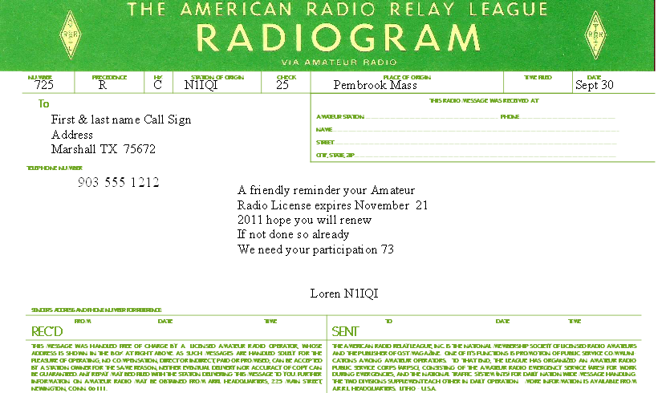

THEN YOUR RETURN MESSAGE WOULD LOOK LIKE THIS
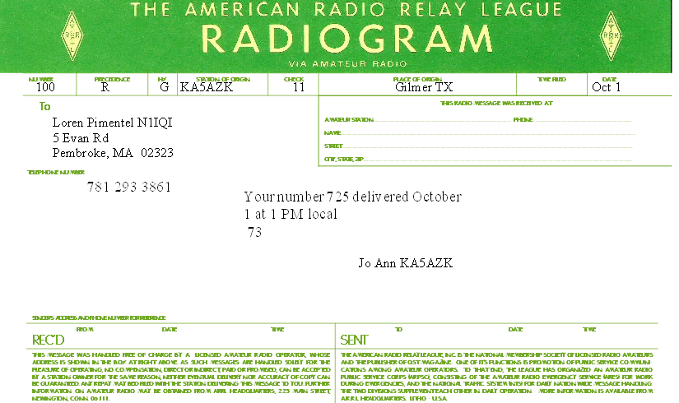

If the Handling Instructions are HXD or HXE the procedure would be the same. Since HXD and HXE have different reply request the text and the check count will be different.

THE ADDRESSEE WANTS TO SEND A REPLY
Sometimes the Handling Instructions will ask for a reply from the addressee or the addressee will want to send a reply. In this case the procedure will be the same just the text and, of course, the check count will be different. Remember that each message you originate should have a different number and keep the text to 25 words or less.

A SERVICE MESSAGE
A service message is a message that, for some reason cannot be delivered. In this case it doesn’t matter what the handling instructions are you will still need to “service it back” to the originator. You may use either the ARL Sixty Seven on the Numbered Radiogram list or simply state that the message cannot be delivered, include the reason and the original message number of the undeliverable message. Your message would look as follows:

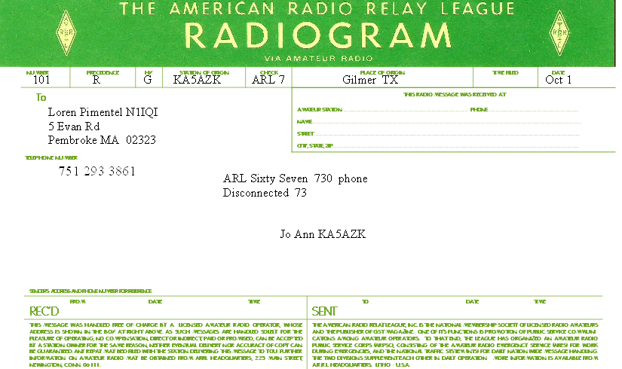

After you have written up your traffic it can be listed on a net. When doing so give your call and wait for the Net Control to acknowledge you and ask you if you have traffic. Then tell the NCS that you have traffic and what city and state it is going to. The NCS will then list it for you. PLEASE DON’T JUST START SENDING YOUR TRAFFIC. It may take awhile for a station to check into the net that can handle your traffic, so if you can’t be on the net the entire time let the NCS know and someone will pick it up for you and relist it or take it to another net.

IN CONCLUSION
The best way to learn traffic handling and net operation is by first listening to the preamble of the net and how they are operating. Then practice writing down traffic that you hear being passed. Then check in and participate. If you are listening to a net and a piece of traffic is being relayed practice writing it down but remember never deliver anything you haven’t acknowledged for. This is the best way for you to become use to the outline of a Radiogram, the speed to send a message and to get over the jitters of taking your first piece. The more you handle traffic, the easier it will become. Most nets will be glad to help you along if it is your first piece of traffic, after all we all had to have our first piece of traffic sometime. The main thing is learn before you need it so that you will be comfortable with checking into nets and handling traffic.

INDEX

Sample Message……………………….....…..14

ARRL FORMS FSD 218 ……………....….....15
ARRL FORMS FSD-3 (Radiograms)…....…...19

ARRL FORMS FSD-220
Procedures & Alphabet)……………................…….......22

Third Party Agreement list………….…..……25
SAR and PSHR Info ………………....….…...27
Traffic Net Schedule List…………….....….….31
National Traffic System (NTS)………....…….32
Additional Resources…………………....……34

QST Articles …................................................35
(Reprinted with permission from ARRL)

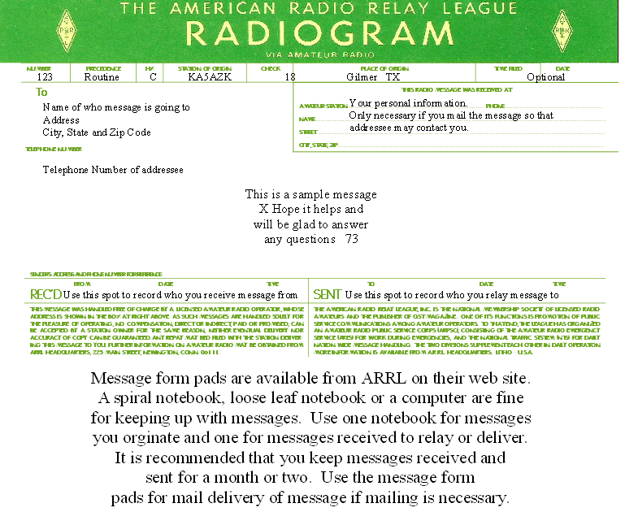

ORIGINAL

91 R HXG KC0M 20 Gilmer TX Jul 28

William Bodine Jr. AB5PM
5321 Carriage Ln
Corpus Christi TX 78415
361-854-3792

Welcome to the 7290 Traffic
Net X we appreciate you
Checking in and hope you
Will join us often 73

KA5AZK Net Manager

RECEIVED

91 R HXG KC7OM 20 Gilmer TX July 28

William Virginia A5PM
53921 Carry Lane
Corpus Christi TX 361-854-3792

Welcome to the 7290 Traffic
Net X we appreciate you
Checking in and hope you
Will continue 73

KA5AZK

EXAMPLE OF WHAT CAN HAPPEN TO A MESSAGE

FSD-218 | Relief Emergency · Routine Messages  Recommended Precedences

Every formal radiogram message originated and handled should contain the following component parts in the order given

I. Preamble

a. Number (begin with 1 each month or year)
b. Precedence (R, W, P or EMERGENCY)
c. Handling Instructions (optional, see text)
d. Station of Origin (first amateur handler)
e. Check (number of words/groups in text only)
f. Place of Origin (not necessarily location of station of origin.)
g. Time Filed (optional with originating station)
h. Date (must agree with date of time filed)

II. Address

(as complete as possible, include zip code and telephone number)

III. Text

(limit to 25 words or less, if possible)

IV. Signature

CW: The prosign separates the parts of the address. separates the address from the text and the text from the signature. marks end of message; this is followed by B if there is another message to follow, by N if this is the only or last message. It is customary to copy the preamble, parts of the address, text and signature on separate lines.
RTTY: Same as CW procedure above, except (1) use extra space between parts of address, instead of ; (2) omit cw procedure sign to separate text from address and signature, using line spaces instead; (3) add a CFM line under the signature, consisting of all names, numerals and unusual works in the message in the order transmitted.
PACKET/AMTOR BBS: Same format as shown in the cw message example above, except that the and prosigns may be omitted. Most amtor and packet BBS software in use today allows formal message traffic to be sent with the “ST” command. Always avoid the use of spectrum-wasting multiple line feeds and indentations.
PHONE: Use prowords instead of prosigns, but it is not necessary to name each part of the message as you send it. For example, the above message would be sent on phone as follows: “Number one routine HX Golf W1AW eight Newington Connecticut one eight three zero zulu July one Donald Smith Figures one six four East Sixth Avenue North River City Missouri zero zero seven eight nine Telephone seven three three four nine six eight Break Happy birthday X-ray see you soon X-ray love Break Diana End of Message Over. “End of Message” is followed by “More” if there is another message to follow, “No More” if it is the only or last message. Speak clearly using VOX (or pause frequently on push-to-talk) so that the receiving station can get fills. Spell phonetically all difficult or unusual words--do not spell out common words. Do not use cw abbreviations or Q-signals in phone traffic handling.

Precedences

The precedence will follow the message number. For example, on cw 207R or 207 EMERGENCY. On phone, “Two Zero Seven, Routine (or Emergency).”
EMERGENCY--Any message having life and death urgency to any person or group of persons, which is transmitted by Amateur Radio in the absence of regular commercial facilities. This includes official messages of welfare agencies during emergencies requesting supplies, materials or instructions vital to relief of stricken populace in emergency areas. During normal times, it will be very rare. On cw, RTTY and other digital modes this designation will always be spelled out. When in doubt, do not use it.
PRIORITY--Important messages having a specific time limit. Official messages not covered in the Emergency category. Press dispatches and other emergency-related traffic not of the utmost urgency. Notifications of death or injury in a disaster area, personal or official. Use the abbreviation P on cw.
WELFARE--A message that is either a) an inquiry as to the health and welfare of an individual in the disaster area b) an advisory or reply from the disaster area that indicates all is well should carry this precedence, which is abbreviated W on cw. These messages are handled after Emergency and Priority traffic but before Routine.
ROUTINE--Most traffic normal times will bear this designation. In disaster situations, traffic labeled Routine (R on cw) should be handled last, or not at all when circuits are busy with Emergency, Priority or Welfare traffic.

Handling Instructions (Optional)

HXA--(Followed by number) Collect landline delivery authorized by addressee within....miles. (If no number, authorization is unlimited.)
HXB--(Followed by number) Cancel message if not delivered within....hours of filing time; service originating station.
HXC--Report date and time of delivery (TOD) to originating station.
HXD--Report to originating station the identity of station from which received, plus date and time. Report identity of station to which relayed, plus date and time, or if delivered report date, time and method of delivery.
HXE--Delivering station get reply from addresses, originate message back.
HXF--(Followed by number) Hold delivery until....(date).
HXG--Delivery by mail or landline toll call not required. If toll or other expense involved, cancel message and service originating station.

For further information on traffic handling, consult the Public Service Communications Manual or the ARRL Operating Manual, both published by ARRL.

ARRL QN Signals For CW Net Use

QNA* Answer in prearranged order.
QNB* Act as relay Between _____ and _____
QNC All net stations Copy. I have a message for all net stations.
QND* Net is Directed (controlled by net control station).
QNE* Entire net stand by.
QNF Net is Free (not controlled).
QNG Take over as net control station.
QNH Your net frequency is High.
QNI Net stations report In.*.
I am reporting into the net. (Follow with a list or traffic or QRU).
QNJ Can you copy me?
Can you copy _____?
QNK* Transmit message for _____ to _____
QNL Your net frequency is Low.
QNM* You are QRMing the net. Stand by.
QNN Net control station is _____
What station has net control?
QNO Station is leaving the net.
QNP Unable to copy you. Unable to copy _____
QNQ* Move frequency to _____ and wait for _____ to finish handling traffic. Then send him traffic for _____
QNR Answer _____ and Receive traffic.
QNS* Following Stations are in the net. *(Follow with list.)
Request list of stations in the net.
QNT I request permission to leave the net for _____ minutes.
QNU* The net has traffic for you. Stand by.
QNV* Establish contact with _____ on this frequency. If successful, move to _____ and send him traffic for _____
QNW How do I route messages for _____?
QNX You are excused from the net.* Request to be excused from the net.
QNY* Shift to another frequency (or to _____ kHz) to clear traffic with _____
QNZ Zero beat your signal with mine.

* For use only by the Net Control Station.

Notes on Use of QN Signals

The QN signals listed above are special ARRL signals for use in amateur cw nets only. They are not for use in casual amateur conversation. Other meanings that may be used in other services do not apply. Do not use QN signals on phone nets. Say it with words. QN signals need not be followed by a question mark, even though the meaning may be interrogatory.

International Q Signals

A Q signal followed by a ? asks a question. A Q signal without the ? answers the question affirmatively, unless otherwise indicated.

QRA What is the name of your station?
QRG What's my exact frequency?
QRH Does my frequency vary?
QRI How is my tone? (1-3)
QRK What is my signal intelligibility? (1-5)
QRL Are you busy?
QRM Is my transmission being interfered with?
QRN Are you troubled by static?
QRO Shall I increase transmitter power?
QRP Shall I decrease transmitter power?
QRQ Shall I send faster?
QRS Shall I send slower?
QRT Shall I stop sending?
QRU Have you anything for me? (Answer in negative)
QRV Are you ready?
QRW Shall I tell _____ you're calling him?
QRX When will you call again?
QRZ Who is calling me?
QSA What is my signal strength? (1-5)
QSB Are my signals fading?
QSD Is my keying defective?
QSG Shall I send _____ messages at a time?
QSK Can you work breakin?
QSL Can you acknowledge receipt?
QSM Shall I repeat the last message sent?
QSO Can you communicate with _____ direct?
QSP Will you relay to _____?
QSV Shall I send a series of V's?
QSW Will you transmit on _____?
QSX Will you listen for _____ on _____?
QSY Shall I change frequency?
QSZ Shall I send each word/group more than once? (Answer, send twice or _____)
QTA Shall I cancel number _____?
QTB Do you agree with my word count? (Answer negative)
QTC How many messages have you to send?
QTH What is your location?
QTR What is your time?
QTV Shall I stand guard for you _____?
QTX Will you keep your station open for further communication with me?
QUA Have you news of _____?

Abbreviations, Prosigns, Prowords

CW PHONE (meaning or purpose)
(Separation between parts of address or signature.).
AA All after (use to get fills).
AB An before (used to get fills).
ADEE Addressee (name of person to whom message addressed).
ADR Address (second part of message).
AR End of message (end of record copy).
ARL (Used with "check," indicates use of ARRL numbered message in text).
Stand by; wait.
B More (another message to follow).
BK Break; break me; break-in (interrupt transmission on cw. Quick check on phone).
Separation (break) between address and text; between text and signature.
C Correct; yes.
CFM Confirm. (Check me on this).
CK Check.
DE From; this is (preceding identification).
(Error in sending. Transmission continues with last word correctly sent.)
HX (Handling instructions. Optional part of preamble.) Initial(s). Single letter(s) to follow.
Repeat; I say again. (Difficult or unusual words or groups.)
K Go ahead; over; reply expected. (Invitation to transmit .)
N Negative, incorrect; no more. (No more messages to follow.)
NR Number. (Message follows.)
PBL Preamble (first part of message)
N/A Read back. (Repeat as received.)
R Roger; point. (Received; decimal point.)
SIG Signed; signature (last part of message.)
Out; clear (end of communications, no reply expected.)
TU Thank you.
WA Word after (used to get fills.)
WB Word before (used to get fills.)
N/A Speak slower.
N/A Speak faster.

FSD-3 | Relief Emergency · Routine Messages  Recommended Precedences

The letters ARL are inserted in the preamble in the check and in the text before spelled out numbers, which represent texts from this list. Note that some ARL texts include insertion of numerals and text. Example: NR 1 R W1AW ARL 5 NEWINGTON CONN. DEC 25 DONALD R. SMITH 164 EAST SIXTH AVE NORTH RIVER CITY MO PHONE 73-3968 ARL FIFTY ARL SIXTY ONE BT DIANA . For additional information about traffic handling, consult The ARRL Operating Manual, published by ARRL, or the NTS Methods and Practices Guidelines, www.arrl.org/FandES/field/nts-mpg/ .

Group One—For Possible “Relief Emergency” Use

ONE Everyone safe here. Please don't worry.

TWO Coming home as soon as possible.

THREE Am in _____ hospital. Receiving excellent care and recovering fine.

FOUR Only slight property damage here. Do not be concerned about disaster reports.

FIVE Am moving to new location. Send no further mail or communication. Will inform you of new address when relocated.

SIX Will contact you as soon as possible.

SEVEN Please reply by Amateur Radio through the amateur delivering this message. This is a free public service.

EIGHT Need additional _____ mobile or portable equipment for immediate emergency use.

NINE Additional _____ radio operators needed to assist with emergency at this location.

TEN Please contact _____. Advise to standby and provide further emergency information, instructions or assistance.

ELEVEN Establish Amateur Radio emergency communications with _____ on _____ MHz.

TWELVE Anxious to hear from you. No word in some time. Please contact me as soon as possible.

THIRTEEN Medical emergency situation exits here.

FOURTEEN Situation here becoming critical. Losses and damage from ____ increasing.

FIFTEEN Please advise your condition and what help is needed.

SIXTEEN Property damage very severe in this area.

SEVENTEEN REACT communications services also available. Establish REACT communication with _____ on channel _____.

EIGHTEEN Please contact me as soon as possible at _____.

NINETEEN Request health and welfare report on _____ . (State name, address and telephone number.)

TWENTY Temporarily stranded. Will need some assistance. Please contact me at _____.

TWENTY ONE Search and Rescue assistance is needed by local authorities here. Advise availability.

TWENTY TWO Need accurate information on the extent and type of conditions now existing at your location. Please furnish this information and reply without delay.

TWENTY THREE Report at once the accessibility and best way to reach your location.

TWENTY FOUR Evacuation of residents from this area urgently needed. Advise plans for help.

TWENTY FIVE Furnish as soon as possible the weather conditions at your location.

TWENTY SIX Help and care for evacuation of sick and injured from this location needed at once.

Emergency/priority messages originating from official sources must carry the signature of the originating official.

Group Two—Routine Messages

FORTY SIX Greetings on your birthday and best wishes for many more to come.

FORTY SEVEN Reference your message number _____ to _____ delivered on _____ at _____ UTC.

FIFTY Greetings by Amateur Radio.

FIFTY ONE Greetings by Amateur Radio. This message is sent as a free public service by ham radio operators at _____. Am having a wonderful time.

FIFTY TWO Really enjoyed being with you. Looking forward to getting together again.

FIFTY THREE Received your _____. It’s appreciated; many thanks.

FIFTY FOUR Many thanks for your good wishes.

FIFTY FIVE Good news is always welcome. Very delighted to hear about yours.

FIFTY SIX Congratulations on your _____, a most worthy and deserved achievement.

FIFTY SEVEN Wish we could be together.

FIFTY EIGHT Have a wonderful time. Let us know when you return.

FIFTY NINE Congratulations on the new arrival. Hope mother and child are well.

*SIXTY Wishing you the best of everything on _____.

SIXTY ONE Wishing you a very Merry Christmas and a Happy New Year.

*SIXTY TWO Greetings and best wishes to you for a pleasant _____ holiday season.

SIXTY THREE Victory or defeat, our best wishes are with you. Hope you win.

SIXTY FOUR Arrived safely at _____.

SIXTY FIVE Arriving _____ on _____. Please arrange to meet me there.

SIXTY SIX DX QSLs are on hand for you at the _____ QSL Bureau. Send _____ self addressed envelopes.

SIXTY SEVEN Your message number _____ undeliverable because of _____. Please advise.

SIXTY EIGHT Sorry to hear you are ill. Best wishes for a speedy recovery.

SIXTY NINE Welcome to the _____. We are glad to have you with us and hope you will enjoy the fun and fellowship of the organization.

* Can be used for all holidays.

ARRL Recommended Precedences

Please observe the following ARRL provisions for PRECEDENCES in connection with written message traffic. These provisions are designed to increase the efficiency of our service both in normal times and in emergency.

EMERGENCY--Any message having life and death urgency to any person or group of persons, which is transmitted by Amateur Radio in the absence of regular commercial facilities. This includes official messages of welfare agencies during emergencies requesting supplies, materials or instructions vital to relief of stricken populace in emergency areas. During normal times, it will be very rare. On CW/RTTY, this designation will always be spelled out. When in doubt, do not use it.

PRIORITY--Use abbreviation P on CW/RTTY. This classification is for a) important messages having a specific time limit b) official messages not covered in the emergency category c) press dispatches and emergency-related traffic not of the utmost urgency d) notice of death or injury in a disaster area, personal or official.

WELFARE--This classification, abbreviated as W on CW/RTTY, refers to either an inquiry as to the health and welfare of an individual in the disaster area or an advisory from the disaster area that indicates all is well. Welfare traffic is handled only after all emergency and priority traffic is cleared. The Red Cross equivalent to an incoming Welfare message is DWI (Disaster Welfare Inquiry).

ROUTINE--Most traffic in normal times will bear this designation. In disaster situations, traffic labeled Routine (R on CW/RTTY) should be handled last, or not at all when circuits are busy with higher precedence traffic.

Note--the precedence always follows the message number. For example, a message number may be 207R on CW and “Two Zero Seven Routine” on phone.

FSD-220 | Communications Procedures · ITU Phonetic Alphabet  R-S-T System · Time Conversion Chart

ARRL Communications Pocedures

Voice | Code | Situation
Go ahead | K | Used after calling CQ, or at the end of a transmission, to indicate any station is invited to transmit.
Over | AR | Used after a call to a specific station, before the contact has been established
 | KN | Used at the end of any transmission when only the specific station contacted is invited to answer.
Stand by or wait | AS | A temporary interruption of the contact.
Roger | R | Indicates a transmission has been received correctly and in full.
Clear | SK | End of contact. SK is sent before the final identification.
Leaving the air or closing the station | CL | Indicates that a station is going off the air, and will not listen or answer any further calls. CL is sent after the final identification.

ITU Phonetic Alphabet

Word list adopted by the International Telecommunications Union

A Alfa
B Bravo
C Charlie
D Delta
E Echo
F Foxtrot
G Golf
H Hotel
I India
J Juliett
K Kilo
L Lima
M Mike
N November
O Oscar
P Papa
Q Quebec
R Romeo
S Sierra
T Tango
U Uniform
V Victor
W Wiskey
X X-ray
Y Yankee
Z Zulu

The R-S-T System

Readability

1 Unreadable
2 Barely readable, occasional words distinguishable.
3 Readable with considerable difficulty.
4 Readable with practically no difficulty.
5 Perfectly readable.

Signal Strength

1 Faint signals, barely perceptible.
2 Very weak signals.
3 Weak signals.
4 Fair signals.
5 Fairly good signals.
6 Good signals.
7 Moderately strong signals.
8 Strong signals.
9 Extremely strong signals.

Tone

1 Sixty cycle a.c or less, very rough and broad.
2 Very rough a.c., very harsh and broad.
3 Rough a.c. tone, rectified but not filtered.
4 Rough note, some trace of filtering.
5 Filtered rectified a.c. but strongly ripple-modulated.
6 Filtered tone, definite trace of ripple modulation.
7 Near pure tone, trace of ripple modulation.
8 Near perfect tone, slight trace of modulation.
9 Perfect tone, no trace of ripple or modulation of any kind.

If the signal has the characteristic steadiness of crystal control, add the letter X to the RST report. If there is a chirp, the letter C may be added to so indicate. Similarly for a click, add K. The above reporting system is used on both cw and voice, leaving out the “tone” report on voice. Turn card over for examples.

Time Conversion Chart

UTC | EDT/AST | CDT/EST | MDT/CST | PDT/MST | PST
0000* | 2000 | 1900 | 1800 | 1700 | 1600
0100 | 2100 | 2000 | 1900 | 1800 | 1700
0200 | 2200 | 2100 | 2000 | 1900 | 1800
0300 | 2300 | 2200 | 2100 | 2000 | 1900
0400 | 0000* | 2300 | 2200 | 2100 | 2000
0500 | 0100 | 0000* | 2300 | 2200 | 2100
0600 | 0200 | 0100 | 0000* | 2300 | 2200
0700 | 0300 | 0200 | 0100 | 0000* | 2300
0800 | 0400 | 0300 | 0200 | 0100 | 0000*
0900 | 0500 | 0400 | 0300 | 0200 | 0100
1000 | 0600 | 0500 | 0400 | 0300 | 0200
1100 | 0700 | 0600 | 0500 | 0400 | 0300
1200 | 0800 | 0700 | 0600 | 0500 | 0400
1300 | 0900 | 0800 | 0700 | 0600 | 0500
1400 | 1000 | 0900 | 0800 | 0700 | 0600
1500 | 1100 | 1000 | 0900 | 0800 | 0700
1600 | 1200 | 1100 | 1000 | 0900 | 0800
1700 | 1300 | 1200 | 1100 | 1000 | 0900
1800 | 1400 | 1300 | 1200 | 1100 | 1000
1900 | 1500 | 1400 | 1300 | 1200 | 1100
2000 | 1600 | 1500 | 1400 | 1300 | 1200
2100 | 1700 | 1600 | 1500 | 1400 | 1300
2200 | 1800 | 1700 | 1600 | 1500 | 1400
2300 | 1900 | 1800 | 1700 | 1600 | 1500
2400* | 2000 | 1900 | 1800 | 1700 | 1600

Universal Coordinated Time (UTC) is the time at the zero or reference meridian. Time changes one hour with each change of 15 degrees in longitude. The five time zones in the US proper and Canada roughly follow these lines.

* 0000 and 2400 are interchangeable. (2400 is associated with the date of the day ending, 0000 with the day just starting.)

International Third-Party Traffic -- Proceed With Caution
Occasionally, DX stations may ask you to pass a third-party message to a friend or relative in the States. This is all right as long as the US has signed an official third-party traffic agreement with that particular country, or the third party is a licensed amateur. The traffic must be noncommercial and of a personal, unimportant nature. During an emergency, the US State Department will often work out a special temporary agreement with the country involved. But in normal times, never handle traffic without first making sure it is legally permitted.

US Amateurs May Handle Third-Party Traffic With:
V2 | Antigua/Barbuda
LO-LW | Argentina
VK | Australia
V3 | Belize
CP | Bolivia
T9 | Bosnia-Herzegovina
PP-PY | Brazil
VE, VO, VY | Canada
CA-CE | Chile
HJ-HK | Colombia
D6 | Comoros (Federal Islamic Republic of)
TI, TE | Costa Rica
CM, CO | Cuba
HI | Dominican Republic
J7 | Dominica
HC-HD | Ecuador
YS | El Salvador
C5 | Gambia, The
9G | Ghana
J3 | Grenada
TG | Guatemala
8R | Guyana
HH | Haiti
HQ-HR | Honduras
4X, 4Z | Israel
6Y | Jamaica
JY | Jordan
EL | Liberia
V7 | Marshall Islands
XA-XI | Mexico
V6 | Micronesia, Federated States of
YN | Nicaragua
HO-HP | Panama
ZP | Paraguay
OA-OC | Peru
DU-DZ | Philippines
VR6 | Pitcairn Island*
V4 | St. Kitts/Nevis
J6 | St. Lucia
J8 | St. Vincent and the Grenadines
9L | Sierra Leone
ZR-ZU | South Africa
3DA | Swaziland
9Y-9Z | Trinidad/Tobago
TA-TC | Turkey
GB | United Kingdom
CV-CX | Uruguay
YV-YY | Venezuela
4U1ITU | ITU - Geneva
4U1VIC | VIC - Vienna

Notes:
* Since 1970, there has been an informal agreement between the United Kingdom and the US, permitting Pitcairn and US amateurs to exchange messages concerning medical emergencies, urgent need for equipment or supplies, and private or personal matters of island residents.
US licensed amateurs may operate in the following US territories under their FCC license:
Please note that the Region 2 Division of the International Amateur Radio Union (IARU) has recommended that international traffic on the 20 and 15-meter bands be conducted on the following frequencies:
14.100-14.150 MHz
14.250-14.350 MHz
21.150-21.200 MHz
21.300-21.450 MHz
The IARU is the alliance of Amateur Radio societies from around the world; Region 2 comprises member-societies in North, South and Central America, and the Caribbean.
Note: At the end of an exchange of third-party traffic with a station located in a foreign country, an FCC-licensed amateur must transmit the call sign of the foreign station as well as his own call sign.

SAR (Station Activity Report)
&
PSHR (Public Service Honor Roll)

Below is a sample message with a summary of your activity for the month. Message should be sent to your Section Traffic Manager at the beginning of each month with the previous month’s activity.

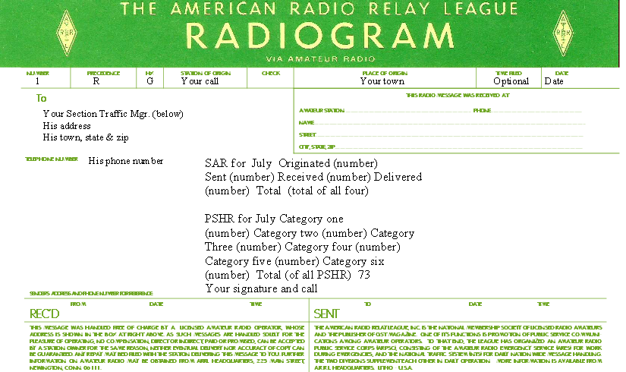

The above message, as written, will exceed the 25 word count limit.
If you do not qualify for all categories of the PSHR
those categories may be left off, which will bring your check
count closer to the 25 limit and you may combine the SAR and PSHR into one radiogram. If you need all categories, then two radiograms may be necessary.

SECTION TRAFFIC MANAGERS

North Texas: ARRON HULETT K8AMH
POB 1664
COPPELL, TX 75019
k8amh@arrl.net

South Texas: RODNEY BAKER W5DY
POB 1237
GOLIAD, TX 77963
rb39@att.net

West Texas: RUSSELL PLOCHECK WE5TXS
2654 GARFIELD
ABILENE, TX 79601
we5txs@suddenlink.net

PSHR
Here is how to count your Public Service Honor Roll points.
The six areas for rating are
- Participating in a public service net (max. 40)
- Handling formal messages (max. 40)
- Serving in an ARRL-sponsored volunteer position (max. 30)
- Participating in a scheduled, short-term public service event, including off-the-air meetings (5 points per hour - no limit)
- Participating in an unplanned emergency response (5 points per hour - no limit)
- Providing and maintaining an automated digital system handling ARRL radiogram-formatted messages or a web page e-mail list server oriented toward Amateur Radio public service. (10 points per item)
Here are the details.
1) Participation in a public service net -- 1 point, maximum 40.
A public service net is one that is regularly scheduled and handles Amateur Radio formal messages. Here are examples of public service nets: Local and section nets that are affiliated with the National Traffic System (NTS); NTS region, NTS area, and independent nets that handle traffic; ARES�, RACES, SKYWARN nets that meet on a regular basis; net sessions that are activated during emergencies and threats of potential emergencies; public service and safety nets; nets that are established for training radio amateurs in public service and emergency communications.
2) Handling formal messages (radiograms) via any mode -- 1 point for each message handled; maximum 40.
A "handled" message is defined as a message that is originated or sent or received or delivered. PSHR will follow the same method as Brass Pounders' League to count an individual operator's traffic total (also known as station activity report) to reach the figure for the new PSHR Category 2. There is one point granted for each message handled; maximum 40 points per calendar month.
Here is a reference from the Public Service Communications Manual on how to count messages. [Section 2, NTS Chapter 10.2] http://www.arrl.org/FandES/field/pscm/sec2-ch10.html#2
Originated--One point for each message from a third party for sending via your station. This "extra" credit is given for an off-the-air function because of the value of contact with the general public.
Sent--Every message sent over the air from your station to another amateur receives a point in this category. Thus, a message that is eligible for an Originated point as above receives another point when it is sent on the air.
Likewise, a message that is received on the air conveys a Sent point when it is relayed to another station. A message that you initiate yourself, while it gets no Originated point, gets a Sent point when cleared. All Sent points require on-the-air sending.
Received--A message received over the air gets a Received point, whether received for relaying (sending) or for delivery to the addressee. Any message received which is not eligible for a Delivery point (such as one addressed to yourself) is nevertheless eligible for a Received point.
Delivered--The act of delivery of a message to a third party receives a point in this category, in addition to a Received point. This is strictly an off-the-air function and must be coupled with receipt of the message at your station. Thus you can't get a Delivered point unless you first get a Received point.
Further example for clarification: If I send a message originated on behalf of myself, I know I get only one point for a message SENT. However, if I originate a message on behalf of a third party, and then send it, I get TWO points, (origination and sending), even though ONE message was handled.
3) Serving in an ARRL-sponsored volunteer position: ARRL Field Organization appointee or Section Manager, NTS Net Manager, TCC Director, TCC member, NTS official or appointee above the Section level. -- 10 points for each position; maximum 30.
ARRL Field Organization appointees (in alphabetical order) include the following: Assistant Section Managers, District Emergency Coordinators, Emergency Coordinators, Local Government Liaisons, Net Managers, Official Bulletin Stations, Official Emergency Stations, Official Observers, Official Observer Coordinators, Official Relay Stations, Public Information Coordinators, Public Information Officers, Section Emergency Coordinators, Section Managers, Section Traffic Managers, State Government Liaisons, Technical Specialists.
The Section Manager is the ARRL-member elected League official the section. NTS Net Managers would include the following nets: NTS Region and NTS Area. TCC (Transcontinental Corps) Director is in charge of organizing his/her TCC membership roster of operators that comprise the corps. TCC members are those operators that are assigned to relay traffic from one NTS area to another, conducting liaison with NTS nets to do so. NTS official or appointee above the Section level includes NTS Area Staff Chairs, NTS Area Digital Coordinators and NTS Digital Stations.
More information about the structure of the NTS and the positions and nets that are mentioned in this article may be found in the ARRL's Public Service Communications Manual. It is on the ARRLWeb.
4) Participation in scheduled, short-term public service events such as walk-a-thons, bike-a-thons, parades, simulated emergency tests and related practice events. This includes off-the-air meetings and coordination efforts with related emergency groups and served agencies. -- 5 points per hour (or any portion thereof) of time spent in either coordinating and/or operating in the public service event; no limit.
This category recognizes the value of public safety communication events that Amateur Radio is often called to participate in. Simulated emergency tests, exercises, and drills are covered by this category. Points are gained by the amount of time that an Amateur Radio operator spends directly involved in operating the event. This also recognizes the value of off-the-air time it takes to meet with the organization or public service agency to plan and coordinate Amateur Radio involvement.
5) Participation in an unplanned emergency response when the Amateur Radio operator is on the scene. This also includes unplanned incident requests by public or served agencies for Amateur Radio participation. --5 points per hour (or any portion thereof) of time spent directly involved in the emergency operation; no limit.
This category recognizes an Amateur Radio operator who is directly involved in an actual emergency operation. This includes the operator who is on the scene or out in the field, in the shelter, at the emergency operations center, at the hospital, or other served agency's headquarters or their temporary command center.
The second sentence of Category 5 invites the Amateur Radio operator who is an active participant in an unplanned incident -- or in other words, an emergency operation-- to take credit for his/her participation even though he/she is not physically at the emergency scene.
The intent behind Category 5 is to also include the Amateur Radio operators -- like net controllers, net operation and other radio amateurs that support communications in unplanned incidents-- that are not actually on the emergency scene or at the shelter, etc, but are spending time and efforts for supporting the same emergency communication efforts.
As an example, if the National Weather Service activates SKYWARN, Amateur Radio operators serve as weather spotters from their home (or car, or work, or other locations) during the weather event. Then, a tornado strikes and the Red Cross calls out the ARES� members to serve in shelters and to provide support for damage assessment communications. These operators would be among those to qualify for points under Category 5.
There would likely be several net control operators, net liaison operators, traffic handlers, etc, who are away from the disaster scene, but are spending time to support the Amateur Radio emergency communication effort on behalf of the served agencies (Red Cross and National Weather Service, in this example). They, too, would qualify for points under Category 5.
6.) Providing and maintaining a) an automated digital system that handles ARRL radiogram-formatted messages; b) a Web page e-mail list server oriented toward Amateur Radio public service -- 10 points per item.
The portion, "a," is a carry-over from the previous PSHR criteria as this sub category recognizes the efforts it takes to provide and maintain an automated digital system (like a packet bulletin board or a PACTOR system) that handles ARRL radiogram-formatted messages.
The portion "b," is a new item. Since the last time PSHR criteria were revised, newer technologies like Web pages and e-mail list servers have become popular and effective ways to communicate news and information to the community of radio amateurs that are involved in emergency and public service communication operations and preparedness.

10.2 Individual Traffic Count
As already mentioned, the individual's traffic count does not have any correlation to the net's traffic count; it is a separate count that each traffic handler should report to his/her Section Traffic Manager or Section Manager each month. Traffic totals may be included in the SM's monthly report. Here are the definitions of each message category:
- Originated -- One point for each message from a third party for sending via your station. This "extra" credit is given for an off-the-air function because of the value of contact with the general public.
- Sent -- Every message sent over the air from your station to another amateur receives a point in this category. Thus, a message that is eligible for an Originated point as above receives another point when it is sent on the air. Likewise, a message that is received on the air conveys a Sent point when it is relayed to another station. A message that you initiate yourself, while it gets no Originated point, gets a Sent point when cleared. All Sent points require on-the-air sending.
- Received -- A message received over the air gets a Received point, whether received for relaying (sending) or for delivery to the addressee. Any message received which is not eligible for a Delivery point (such as one addressed to yourself) is nevertheless eligible for a Received point.
- Delivered -- The act of delivery of a message to a third party receives a point in this category, in addition to a Received point. This is strictly an off-the-air function and must be coupled with receipt of the message at your station. Thus you can't get a Delivered point unless you first get a Received point.

Traffic Net Schedule

Texas and Southwestern US
Updated 06-01-2019
Times shown are local (central). Frequency SSB except where indicated. Dy = Daily.
Please suggest additions.
Time | Frequency | Days | Name
08:30 - 09:30 AM | 7285 | M-Sat | Texas Traffic Net  www.texastrafficnet.net
10:00 AM  12:00 | 7290 | M-Sat | 7290 Traffic Net  www.7290trafficnet.org
10:30 AM | 7280 | M-Sat | Fifth Region Cycle 1
01:00 - 02:00 PM | 7290 | M-F | 7290 Traffic Net  www.7290trafficnet.org
01:30 PM | 7280 | Sun | Fifth Region Cycle 1
02:15 PM | 14345 | Dy | Central Area Net Cycle 2
03:30 PM | 7243 | Dy | Fifth Region Cycle 2
05:20 PM | 7120.6 | Dy | Oklahoma Slow Speed Training Net
06:30 - 07:30 PM | 3873 | Dy | Texas Traffic Net  www.texastrafficnet.net
06:30 PM | 146.88 –  PL 110.9 | Dy | Dallas Metro Traffic Net  www.dfwtrafficnet.com
06:30 PM | 3552 | Dy | Oklahoma Net (CW)
07:00 PM CST  08:00 PM CDT | 3935 | Dy | Central Gulf Coast Hurricane Net
07:00 PM | 3541 or  7108 or 3643 Contest* | Dy | Texas CW Traffic Net (TEX)  http://k6jt.com
07:30 PM | 3567 W or  7045 S | Dy | Fifth Region Cycle 4 (CW)
07:45 PM | 3570 | Dy | Texas Slow CW Net  http://www.atcweb.com/tsn/Texas_Slow_Net
08:30 PM | 3552 W  7052 S | Dy | Central Area Net Cycle 4 (CW)
09:30 - 10:30 PM | 3935 | Dy | Southwest Traffic Net
09:30 PM | 3567 | Dy | Fifth Region Cycle 4 (CW)
10:00 PM | 3541 New Freq  3643 During Contest* | Dy | Texas CW Traffic Net (TEX)  http://k6jt.com
10:30 PM | 146.72 -  PL 110.9 | Dy | Dallas Metro Traffic Net www.dfwtrafficnet.com
ARES, RACES, and Emergency Nets
08:00 AM | 3835 | 2 Sat | Texas Red Cross Net
07:30 PM | 3873 | Mon. | Texas ARES Net
01:30 PM | 7248 | 1,3,5 Sn | District 32 RACES
01:30/02:00 PM | 3975/7255 | 2 & 4 Sn | RACES Net
08:00 AM | 3910 | Sun | Central Texas Emergency Net
09:00 AM | 3905 | M-Sat | SATERN Net
As Req. | 7285  3873 | Day  Night | Emergency & Tactical Traffic Net
As Req. | 7290 | Day | 7290 Traffic Net Extended Sessions  Health and Welfare
As Req. | 3935 | Night | Gulf Coast Hurricane Net  Health and Welfare
*NOTE: 7108 is used during the summer only, and is an alternate frequency at the discretion of the NCS when band conditions warrant. ALSO, 3643 is used ONLY on Friday and Saturday evenings when a major CW contest is in progress.
Thanks to Rodney W5DY for his help updating this list.
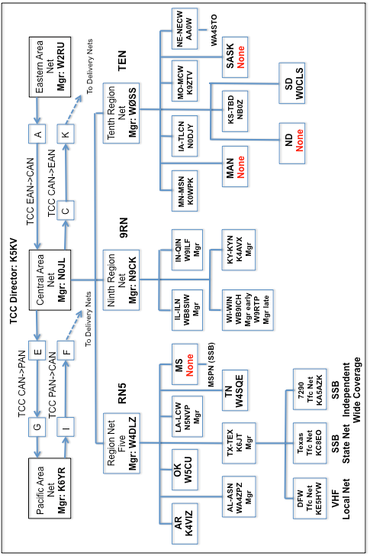
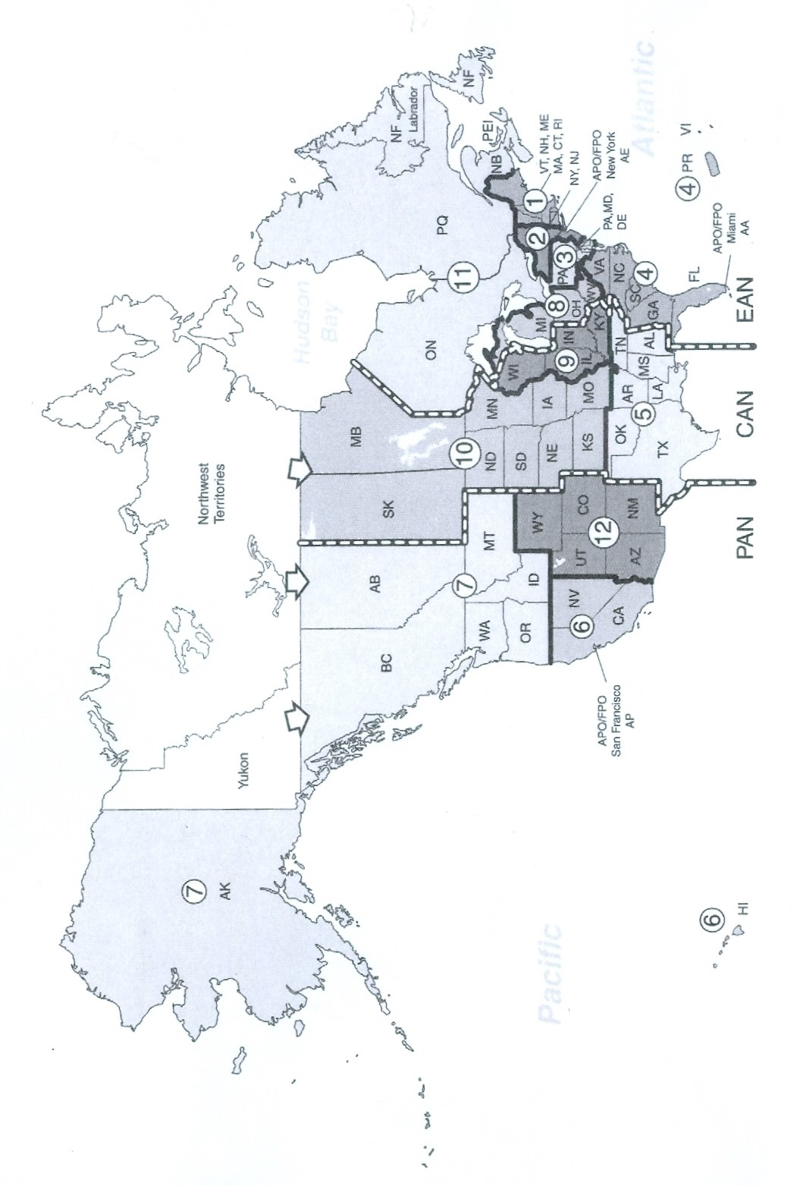

Additional Resources

ARRL Net Directory – Excellent NTS reference with net listings by state ($5 fromARRL). Online version is accessible free at the ARRL web site (www.arrl.org).

Public Service Communication Manual – Detailed reference on NTS message handling on ARRL web site.

Winlink 2000 web Site http://www.winlink.org

Central Area NTS Status White Paper (K6JT)
http://dl.dropboxusercontent.com/u/73013707/NTS%20Status.pdf

TEX Website (www.k6jt.com),
7290 Traffic Net (www.7290trafficnet.org),
DFW TrafficNet (www.dfwtrafficnet.org),
Texas Traffic Net (www.texastrafficnet.org)

W Gulf Division Director  John Stratton N5AUS  POB 2232  Austin, TX 78768 512-445-6262  n5aus@n5aus.com | North TX Section Manager  Steven Loft Smith KG5VK  125 Contest Lane  Ben Franklin, TX 75415 318-470-9806  kg5vk@arrl.org
W Gulf Division Vice Director  Lee Cooper W5LHC  2507 Autrey Dr.  Leander, TX 78641 512-658-3910  lcooper@arrl.org | South TX Section Manager  Paul Gilbert KE5ZW  1209 Doris Lane  Cedar Park, TX 78613 512-940-0441  ke5zw@arrl.org
West TX Section Manager
Dale Durham W5WI
POB 375
Buffalo Gap, TX 79508 830-719-9000
w5wi@arrl.org

ARRL W Gulf Division N TX http://arrlwgd.org/ & http://www.arrl.org/sections/view/north-texas

ARRL W Gulf Division S TX http://www.arrlstx.org. & http://www.arrl.org/sections/view/south-texas

ARRL W Gulf Division W TX http://www.arrlstx.org. & http://www.arrl.org/sections/view/south-texas
www.arrl.org ARRL web page

QRZ.com for looking up call sign information


